**Advertiser Reporting UI**

*Development Document -V1.0*

Revision History:

| **Version** | **Date** | **Name** | **Reason** |
| --- | --- | --- | --- |
| 1.0 | 10/18/2013 | Nhut | Initial Draft |
|  | 10/23/2013 | Chinh Nguyen |  |
|  | 17/03/2014 | Chinh Nguyen |  |

**TABLE OF CONTENT**

1. Introduction: 2

1.1. Document Purpose and Scope: 2

1.2. Definition, Acronyms and Abbreviations: 2

2. System requirements: 2

2.1. Hardware requirement: 2

2.2. Software & Libraries for development: 2

2.3. Report UI requirement: 2

3. Development 3

3.1. Environment 3

3.2. Modules 3

3.3. Data Flow Overview 5

3.4. Advertiser API 5

3.5. Advertiser Dashboard 6

3.6. Campain Name 7

1. Introduction:

The purpose of Advertiser Reporting UI project is to provide:

* Automated, on-demand reporting tools for customers to minimize internal resource demands and make customers happier.
* Allow publisher reporting and advertising reporting to share benefits of improved reporting
* Develop a single point of truth / system of record for reporting data.
  1. **Document Purpose and Scope**:

This document provides an overview of the system requirements (hardware, software), architecture and design of the Advertiser Reporting UI tool. Data managers, designers, and developers would use this document for development and maintenance.

* 1. Definition, Acronyms and Abbreviations:

1. System requirements:
   1. Hardware requirement:
   2. Software & Libraries for development:

* Eclipse EE
* A tool to develop java web application.
* iReport Designer
* A tool to design reports.
* JasperReports Library
* Use this library to export jasper reports to PDF, Excel…
* Version 3.7
* Bootrap 3 - front-end framework
* Version 3
* Bootstrap is a free collection of tools for creating websites and web applications.
* It contains HTML and CSS-based design templates for typography, forms, buttons, navigation and other interface components, as well as optional JavaScript extensions.
* This style is same as the [style used in requirement](https://wiki.vervemobile.com/confluence/download/attachments/41582915/style%20sheet.jpg?version=1&modificationDate=1376581440000).
* Link: <http://getbootstrap.com/getting-started/#download>

Refer to the confluence page for requirement: <https://wiki.vervemobile.com/confluence/display/TD/Advertiser+Reporting>

* 1. Report UI requirement:
* Web interface
* Provide an interface for user view reports via web browser.
* Api interface
* Provide an interface for user can access data via available web api.

1. Development
   1. Environment

* Server environment
* Dw0
* JRE 6 - The Java Runtime Environment
* Requirements for executing a Java application. It consists of the Java Virtual Machine (JVM), core classes, and supporting files.
* Require by Tomcat.
* JasperReports Library is library coded by java, so we need install JRE to use this library.
* Apache Tomcat 6
* dw0: /opt/pentaho/biserver-ce/tomcat
* Apache Tomcat (or simply Tomcat, formerly also *Jakarta Tomcat*) is an open source web server and servlet container developed by the Apache Software Foundation (ASF).
* We have many tomcats server available on our system, so we don’t need to install a new tomcat server.
  1. Modules
* Api module
* A java web application receive requests from client look like *http://reportings.vervemobile.com/advertiserapi /AdCel?by=full_date&where[date]=2013-10-10* and then return a Json object or csv content.
* URL to access API Guide: [*http://reporting.vervemobile.com/advertiserapi*](http://reporting.vervemobile.com/advertiserapi)
* The folder deploy app: *dw0: /opt/pentaho/biserver-ce/tomcat/webapps/advertiserapi*

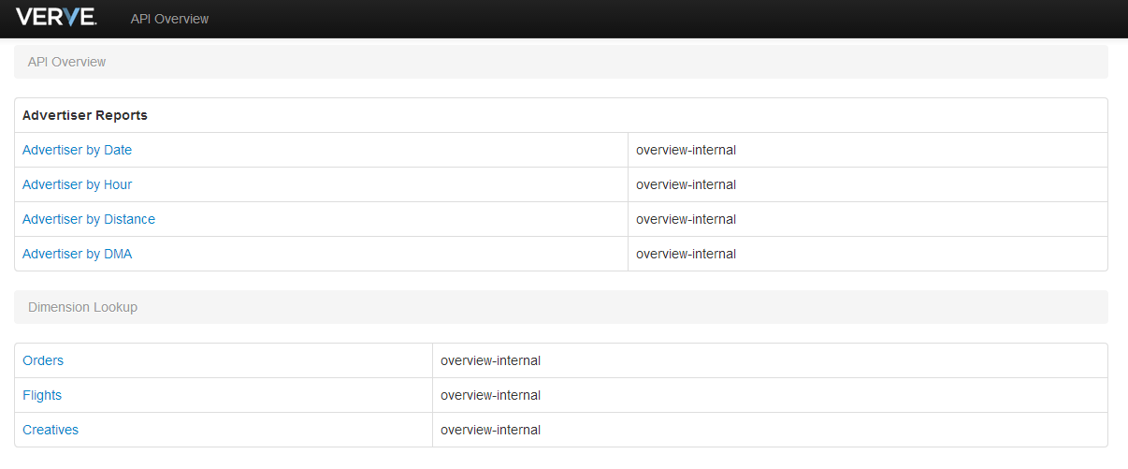

* Advertiser dashboard
* A java web application provide an web interface for users access advertiser reports.
* Address to access: *http://reporting.vervemobile.com/AdvertiserDashboard*
* Deploy in folder: *dw0: /opt/pentaho/biserver-ce/tomcat/webapps/AdvertiserDashboard*

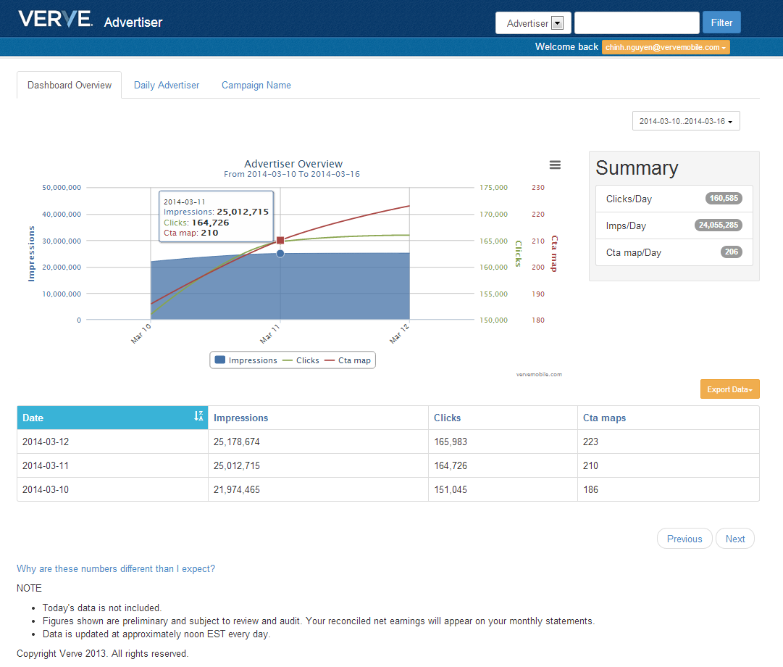

* 1. Data Flow Overview

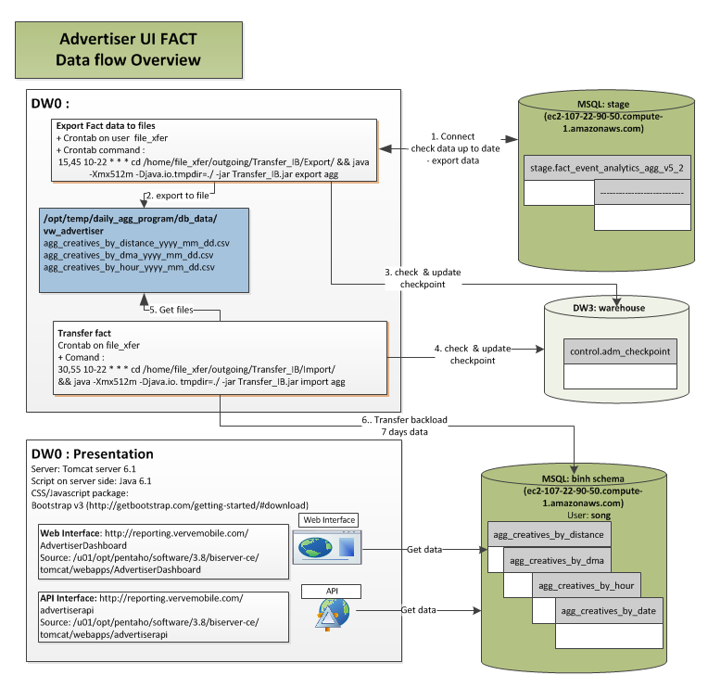

* 1. Advertiser API
* Access URL
* http://reporting.vervemobile.com/advertiserapi
* Source
* /u01/opt/pentaho/software/3.8/biserver-ce/tomcat/webapps/advertiserapi
  + 1. [Advertiser by Date](http://reporting.vervemobile.com/advertiserapi/ApiOverviewDetail?api=advertiserByDate)
* Access URL: http://reporting.vervemobile.com/advertiserapi/AdvertiserByDate
* Data source: **agg_creatives_by_date**
  + 1. [Advertiser by Hour](http://reporting.vervemobile.com/advertiserapi/ApiOverviewDetail?api=advertiserByHour)
* Access URL: *http://reporting.vervemobile.com/advertiserapi/AdvertiserByHour*
* Data source: **agg_creatives_by_hour**
  + 1. [Advertiser by Distance](http://reporting.vervemobile.com/advertiserapi/ApiOverviewDetail?api=advertiserByDistance)
* Access URL: *http://reporting.vervemobile.com/advertiserapi/AdvertiserByDistance*
* Data source: **agg_creatives_by_distance**
  + 1. [Advertiser by DMA](http://reporting.vervemobile.com/advertiserapi/ApiOverviewDetail?api=advertiserByDma)
* Access URL: *http://reporting.vervemobile.com/advertiserapi/AdvertiserByDma*
* Data source: **agg_creatives_by_dma**
  + 1. Dimension Lookup
* Orders
* Access URL: *http://reporting.vervemobile.com/advertiserapi/LookupOrders*
* Data source: **dim_orders**
* Flights
* Access URL: http://reporting.vervemobile.com/advertiserapi/LookupFlights
* Data source: **dim_flights**
* Creatives
* Access URL: http://reporting.vervemobile.com/*advertiserapi/LookupCreatives*
* Data source: **dim_creatives**
  1. Advertiser Dashboard
     1. Dashboard overview

This page presents an overview of impressions, clicks and CTA map values group by date

* Data source from table: **agg_creatives_by_date**
* Api access: *http://reporting.vervemobile.com/advertiserapi/AdvertiserByDate*
* Script Files
* Control Script: *WebContent/scripts/control/dashboardOverview.js*
* Interface: *WebContent/overview.jsp*
* Summary area
* Clicks/Day: the average number of clicks per day
* Imps/Day: the average number of impressions per day
* Cta map/Day: the average number of Cta_map per day
  + 1. Daily Advertiser

This page presents a detail of impressions, clicks and CTA map values in hours, distance and dma group by date

* Data source from table: **agg_creatives_by_hour, agg_creatives_by_distance, agg_creatives_by_dma**
* Api access:
  + http://reporting.vervemobile.com/advertiserapi/AdvertiserByHour
  + http://reporting.vervemobile.com/advertiserapi/AdvertiserByDistance
  + http://reporting.vervemobile.com/advertiserapi/AdvertiserByDma
* Script Files
* Control Script:
  + *WebContent/scripts/control/dailyAdvertiserPage.js*
  + *WebContent/scripts/control/dailyAdvertiserPage_dma_control.js*
* Interface: *WebContent/dailyAdvertisers.jsp*
  1. Campain Name

--Processing…